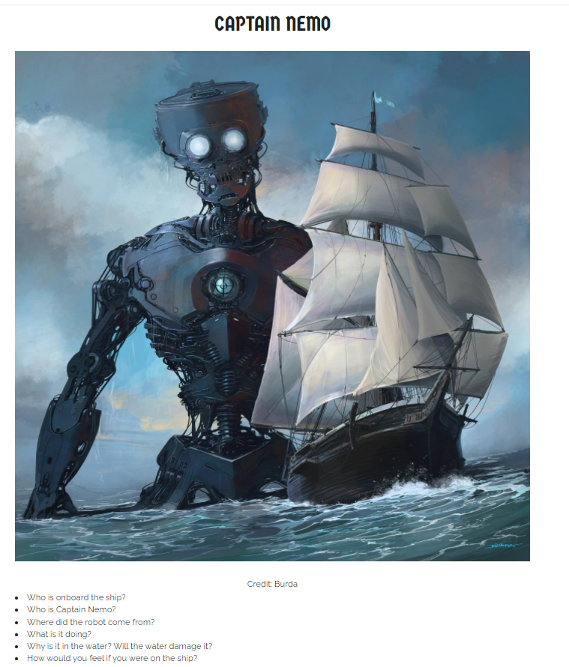

- Who is onboard the ship?
- Who is Captain Nemo?
- Where did the robot come from?
- What is it doing?
- Why is it in the water? Will the water damage it?
- How would you feel if you were on the ship?
- What will happen next?
- Tell this story.

