

Fairburn View Primary School
School Development Plan updated 12.06.25 15.09.25 12.01.26 14.06.26

2025 – 2026

PURPOSE AND PROCESS
- The Fairburn View School Development Plan enables the school’s vision to be shared and understood by the whole school community. It gives all stakeholders an understanding of where the school is moving and what actions will be taken to further secure and sustain improvement. The School Development Plan is designed to give a sharp, clear focus to those aspects of the school’s work which are believed to be most in need of improvement and brings together, in one purposeful, practical and coherent plan, national, local and school priorities, reflecting the aims and values of the school. It links directly to the areas identified by the school’s self-evaluation and by any external evaluation such as Ofsted.
- As part of this process, a range of information is gathered and evaluated, and key priorities are then identified. The information evaluated includes a review of the previous year’s actions and their impact, robust analysis of assessment data, information about pupils’ behaviour and attitudes, attendance, monitoring evidence, external reports and the views of stakeholders.
- Once key priorities have been identified and agreed, senior leaders develop action plans. Clear objectives, actions, timescales and success criteria are agreed. Resources to support specific actions are also identified; this helps leaders plan and prioritise budget spending and guides staff training.

INFORMATION ABOUT OUR SCHOOL
CHARACTERISTICS AND CONTEXT OF THE SCHOOL:  Fairburn View Primary School is a larger than average primary school with 504 pupils currently on role, including 23 children accessing Little Ducklings 2 year old Nursery Provision (June 2025). It is situated in Airedale, Castleford and the majority of pupils are White British in heritage. The proportion of EAL pupils on roll is 7.5%, well below the national average of 38.4%. The proportion of pupils that are disadvantaged is 56.2%, which is well above the national average (26%) Pupils known to be eligible for the pupil premium grant is 46.3%, which is well above the national average (25.7%). The proportion of pupils who have SEN and/or disabilities is 18.4%; this is above the national average (14.2%). The proportion of pupils with an Education, Health and Care Plan is 3.5%; this is below the national average (5.3%). The school has an average IDACI score of 0.33(LA Avg = 0.20) placing it 108th in the Wakefield Local Authority out of 113 (Jan 24 census).  The Senior Leadership Team consists of the Head Teacher, Deputy Head Teacher and two Assistant Head Teachers.
  Attendance  2024-25 (May 2025) |  | 25/26 YTD  (CSA)
  Whole School (CSA) | 91.3% | 91.3%
  Little Ducklings | 84.8% | 81.8
  Nursery | 87% | 87.1
  Reception | 91% | 90.8
  Year 1 | 87.8% | 92.5
  Year 2 | 92.9% | 87.9
  Year 3 | 90.7% | 90.7
  Year 4 | 91.7% | 91.4
  Year 5 | 91.8% | 90.7
  Year 6 | 91.9% | 91.9
  Boys | 90.4% | 89.9 (90.1)
  Girls | 92.5% | 91.7 (92.5)
  Disadvantaged | 89.1% | 88.6 (88.7)
  SEN  (with EHCP) | 87.1% | 89 (89.3)  83.8 (84.4)
  Persistent  Absence | 28.9% | 33.1 (28)
  Authorised Absence | 6.1% | (6.5)
  Unauthorised Absence | 3.3% | (2.9)
Key Outcomes
2025 Attainment results
 |  | EYFS GLD |  | Phonics (Y1) |  | Phonics re-check (Y2) |  | MTC Average Score (Y4) |  | MTC Full Marks
School |  | 47% |  | 53% |  | 35% |  | 19.3 |  | 21%
National |  | 68% |  | 80% |  | 0% |  | 21.1 |  | -
KS2 |  |  | Achieved the Expected Standard |  |  | Achieved the Higher Standard |  |  | Average Scaled Score
KS2 |  |  | School |  | National | School | National |  | School |  | National
KS2 | Reading |  | 60% |  | 75% | 13% | 33% |  | 102 |  | 106
KS2 | Writing |  | 47% |  | 72% | 0% | 13%
KS2 | Maths |  | 55% |  | 74% | 8% | 26% |  | 100 |  | 105
KS2 | GPS |  | 47% |  | 73% | 5% | 30% |  | 100 |  | 105
KS2 | RWM Combined |  | 30% |  | 62% | 0% | 8%

2024 Attainment results
 |  | EYFS GLD |  | Phonics (Y1) |  |  | Phonics re-check (Y2) |  |  | MTC Average Score (Y4)
School |  | 38% |  | 67% |  |  | 75% |  |  | 18.7
National |  | 68% |  | 80% |  |  | 55% |  |  | 20.6
KS2 |  |  | Achieved the Expected Standard |  |  | Achieved the Higher Standard |  |  | Average Scaled Score
KS2 |  |  | School |  | National | School |  | National | School |  | National
KS2 | Reading |  | 80% |  | 74% | 11% |  | 28% | 104 |  | 105
KS2 | Writing |  | 57% |  | 72% | 4% |  | 13%
KS2 | Maths |  | 86% |  | 73% | 14% |  | 24% | 104 |  | 104
KS2 | GPS |  | 82% |  | 72% | 23% |  | 32% | 105 |  | 105
KS2 | RWM Combined |  | 55% |  | 61% | 0% |  | 8%

Prior Data
Early Years Foundation Stage - GLD
2019 | 2021 (Non-statutory) | 2022 | 2023 | 2024
52% | 30% | 54% | 50% | 38%

Year 1 - Phonics Screening Check (32+)
2019 | 2021 (Non-statutory) | 2022 |  | 2023 |  | 2024
64% | 55% | Y1 58% | KS1 80% | Y1  61% | KS1 73% | Y1  67% | KS1  90%

Year 4 – Multiplication Tables Check (out of 25)
2022 |  | 2023 |  | 2024 |  | 2025
Avg Score | % Scoring 21-25 | Avg Score | % Scoring 21-25 | Average Score | % Scoring 21-25 | Average Score | % Scoring 21-25
17.9 | 46% | 18.0 | 48% | 18.7 | 56% | 19.3 | 51.6%

End of Key Stage 2 – Year 6
 | 2019 |  |  |  | 2021 (Non-statutory) |  | 2022 |  |  |  | 2023 |  |  |  | 2024
 | % At Expected (inc GD) | % GD | Progress Measure | Ave. Scaled Score | % At Expected (inc GD) | % GD | % At Expected (inc GD) | % GD | Progress Measure | Ave. Scaled Score | % At Expected (inc GD) | % GD | Progress Measure | Ave. Scaled Score | % At Expected (inc GD) | % GD | Progress Measure | Ave. Scaled Score
Reading | 80% | 16% | 1.1 | 103 | 46% | 7% | 68% | 23% | 0.2 | 103 | 70% | 28% | 2.5 | 105 | 78% | 10% | - | 104.6
Writing | 69% | 16% | 1.0 |  | 43% | 5% | 48% | 2% | -3.0 |  | 53% | 0% | -2.3 |  | 55% | 3%
Maths | 82% | 20% | 2.3 | 104 | 41% | 7% | 72% | 17% | 1.2 | 103 | 68% | 12% | 0.7 | 101 | 83% | 14% |  | 104.1
SPaG | 73% | 14% |  | 102 | 41% | 10% | 45% | 13% |  | 100 | 65% | 7% |  | 101 | 69% | 27% | - | 104.2
RWM | 63% | 8% |  |  | 34% | 3% | 45% | 2% |  |  | 50% | 0% |  |  | 53% | 0%

WHOLE SCHOOL PRIORITY 1: |  |  | LED BY:
To develop the teaching of early reading to ensure higher outcomes for pupils in the Y1 Phonics Screening Check. |  |  | Alex Webb  Claire Barker  Jaime McMillan
CONTEXT STATEMENT – WE HAVE CHOSEN THIS BECAUSE:
- The school currently use Sounds Write as a Phonics scheme, and has done for several years, however the phonics screening data shows that the data is well below the national average for Y1.
- Feedback from the English Hub during their time supporting the school, has been the Sounds Write is not an effective phonics scheme for the school. It has been difficult for them to effectively support with the development and teaching of phonics, as it is not a scheme that the supporting practitioners are familiar with.
- We are implementing a more appropriate Systematic Phonics Programme so that the teaching of early reading will be more consistent across EYFS and KS1. All children will receive the same quality phonics teaching and therefore become more confident, fluent readers. This will be reflected in a rise in the Year PSC results and the amount of children reading at ARE at the end of the KS1.
- We have spent time observing practice in local schools to determine which phonics scheme would be most appropriate for the context of the school, and have purchased a subscription to Little Wandle.

OVERALL SUCCESS CRITERIA:
- The percentage of pupils meeting the Year 1 Phonics screening will rise next academic year, rising to being in-line with National by the June 2027.
- Monitoring and observations of phonics will show that there is a consistent, high quality approach with fidelity to the Little Wandle scheme.
- Children who need extra support will be identified and support through daily intervention.
- Children who have not passed their phonics screening check by the end of KS1, will continue to be taught using the rapid catch up in KS2. The number of children needing rapid catch-up will decrease significantly.

KEY OBJECTIVE | ACTIONS |  |  | WHO |  | RESOURCES
Little Wandle will be implemented so that the teaching of phonics is consistent and children have a solid foundation to build upon | - Training given to all staff around implementing the programme.  - Support and training from the English Hub to ensure consistency in delivery.  - Purchase phonetically matched books and resources linked to Little Wandle  - Staff groups to visit other settings that deliver Little Wandle effectively. |  |  | CB |  | Little Wandle Champion School Day – 18th June 25 (CB/AW)  Training for key staff to deliver the Programme x4 sessions (Summer)  Purchase of SSP and phonetically decodable books:  £10,066.68 – starter pack plus resources  £300 – ebooks subscription  £851.92 – additional resources after placement tests
To ensure that children who need extra support with early reading and phonics are identified and support put in place | - Early reading leader in place to run training and phonics intervention groups  - Screening of all pupils in R, Y1 and Y2 in Autumn 1 to ensure that children who need extra support are identified early.  - Training given to key members of staff to deliver phonics effectively.  - Observation and monitoring of phonics sessions to ensure consistency  - Children who did not pass the phonics test in KS1 will be identified and addition support put in place (rapid catch up)  - Class teachers will identify the bottom 20% of readers and these children will receive daily reading / comprehension catch up. |  |  | Class teachers  CB to monitor |  | Early Reading / Phonics leader release time
To ensure that staff receive high quality training to enable them to deliver high quality phonics sessions. | - Training for all staff (including support staff) on the delivery of the SSP  - Coaching for key staff from the phonics lead and English Hub  - Observations of phonics sessions and reading sessions to ensure consistency  - Training for all staff on how to hear children read effectively |  |  | CB |  | Early Reading / Phonics leader release time
MILESTONES
By the end of Summer: |  | By the end of Autumn: | By the end of Spring: |  | By the end of Summer:
- Audit of current phonics programme undertaken and an SSP identified- Little Wandle  - Resources and books to deliver Little Wandle ordered and organised  - Little Wandle Training Sessions (x4) for all staff  - Assessment of Reception and Y1 pupils carried out to ensure starting points are identified for Autumn 1 for Y1  - Online Assessments of Y2 and KS2 pupils carried out to ensure rapid catch up groups are in place for Autumn 1 for KS2  - Bespoke training/coaching given to key members of staff so that they are confident in the delivery of phonics |  | - Children who are not on track for ARE identified and catch up support with be in place.  - The number of children in KS2 who are accessing rapid catch up will have decreased.  - Lesson observations will show that the teaching of phonics is consistent. Ongoing coaching needed in Y1.  - Bespoke training/coaching given to key members of staff so that they are confident in the delivery of phonics. Carried over from Autumn Term. | - Little Wandle assessments will show that the % of children that are on track for meeting ARE has increased from the Autumn term in line with Little Wandle expectations of where pupils should be.  - Lesson observations will show that the teaching of phonics is consistent. Specific support and ongoing CPD identified by Phonics Lead, including engagement with the Little Wandle Champion School (Bradford).  - Children’s mock PSC will improve from their starting points in Autumn 1 - Vast majority of pupils, including Y2 rec-check pupils.  - The number of children in KS2 who are accessing rapid catch up will have decreased. 18 KS2 children (Y3/4) are now accessing bespoke phonics. |  | - The percentage of children reaching ARE for phonics in Y1 will show an improvement from last year.2025 53% to 2026 61.4%  - The percentage of children in Y2 reaching ARE in the PSC re-check will be in 90%. – 67% reached. 84.9% as a full cohort  - Year 2 of implementation and training needs will be planned for. – To be planned by CB now we have phonics screening data and staffing sorted for 26/27  - To develop a strong reading culture and a love of reading across school. – Currently developing this but this will go on into 26/27.  - Outwood English Hub Audit day planned – June 26.  - Additional phonics take home books purchased due to low uptake of Collins Online (£4500)  - 26/27:  -CPD attendance at Little Wandle Champion School  - Support through Outwood English Hub following June 26 Audit  - The majority of pupils transition from Rec to Y1 will be accessing phonics at Y1 Autumn Term  -All children will be able to take a reading book home each week

WHOLE SCHOOL PRIORITY 2: |  |  | LED BY:
To establish clear, consistent approaches to delivering the writing curriculum so that all children make good or better progress. |  |  | Alex Webb  Marissa Cox
CONTEXT STATEMENT – WE HAVE CHOSEN THIS BECAUSE:
- The percentage of children achieving GLD is significantly lower than national.
- The Writing ARE outcomes at the end of KS2 are lower national, which caps RWM combined at significantly lower than national (inc historic data to 2022)
- The percentage of children reaching GDS at the end of KS2 are significantly lower than national.
- Staff voice suggests that they feel they need a structure for teaching writing effectively.
OVERALL SUCCESS CRITERIA:
- The writing curriculum will have a genre overview for the whole school.
- The writing curriculum will be planned and sequenced so that new skills build on what has been taught before, and towards end of term/year expectations.
- Books will show a progression in skills and knowledge taught across the year groups in writing.
- Teachers will be able to use termly expectations to make accurate judgements of writing.
- Writing outcomes will increase across every year group.
KEY OBJECTIVE | ACTIONS |  |  | WHO |  | RESOURCES
That curriculum map shows a clear progression of genres, purpose, audience and skills. | - Subject leader has regular time to develop a curriculum map from EYFS to Y6 to ensure coverage of NC skills, and the full range of genres.  - Subject leader will implement use of skills progression documents to ensure planning is building upon prior learning.  - Subject leader will deliver CPD to all staff. |  |  | MC/AW/LP |  | Subject leader release time  2 hours per week  CPD through WES and external providers for new writing lead:  - The Writing Framework – An overview for school leaders £68.25  - English Network – Termly Sessions £362.25  - Leading the way to successful spelling £120  - Spelling Unpacked £120  Moderation CPD through WES for class teachers  Moderation planned into staff meeting time
That pupil’s books evidence good progress, have a clear sequence of skills taught, demonstrating high quality independent writing. | - Subject leader has regular time to undertake work scrutiny to check on progress and sequencing in books across the writing curriculum.  - CPD for all staff around the writing cycle to support teaching sequence including hooks and purpose, high quality WAGOLLs, and explicit teaching of editing. |  |  | MC/AW
The curriculum is having a positive impact on pupil’s outcomes and assessment supports this. | - CPD to support teacher assessment judgements, using termly expectations documents.  - Moderation support for teachers.  - Whole school target setting for writing. |  |  | AW/JM/MC
There will be an effective strategy for teaching spelling, to reduce one of the barriers for children achieving the expected standard. | - Implement baseline assessments, and analysis of data to support effective grouping of children.  - Support teachers with cross year group/phase working to utilise staff effectively.  - Monitor use of Spelling Shed across school. |  |  |  |  | - Cost of Spelling Shed as a scheme  £----
MILESTONES
By the end of Autumn: |  | By the end of Spring: |  |  | By the end of Summer:
- All children will be accessing spelling groups that are appropriate for their ability to ensure gaps from KS1 and previous years in KS2 have been addressed.  - All pupils from Y1 upwards will have a least 2 pieces of independent writing by the end of Autumn 1, and 5 by the end of Autumn 2. (Need to check this in book look)  - Teachers will be able to make judgements based on skills taught of pupil’s writing. (In the process of developing the writing curriculum which includes which skills need to be covered and when. As teachers are using new text drivers from Jan, we will be able to monitor this at the next moderation)  - Any children not on track to reach their end of year target will have been identified at Pupil Progress meetings, and a plan made to support them. (Need to confirm when Pupil Progress Meetings are being held). |  | - The majority of pupils will be on track to achieve the end of year targets that they have been set.  - Children that are not on track to meet their end of year target will have been supported through appropriate intervention.  - All pupils from Y1 upwards will have at least 9 pieces of independent writing.  - Books will show a consistent approach to teaching writing.  - Children that are accessing spelling at a significantly lower level will have made progress towards ARE.  - Any children not on track to reach their end of year target will have been identified at Pupil Progress meetings, and a plan made to support them. |  |  | - The majority of pupils will achieve the end of year targets that they have been set.  - The majority of pupils will be accessing spelling sessions at their year group level.  - All children will have written for a range of purposes and audiences over the year.  - Children will show an improved understanding of SPAG within their year group.  - Children that are not on track to meet their end of year target will have been supported through appropriate intervention.  - Writing Lead to continue to attend each year group moderation session with class teachers within the LA.  - 26/27:  -Termly moderation with Castleford Trust, and attendance at Writing Working Group  -Continued support from LA – JM/JN delivering CPD and supporting with monitoring

WHOLE SCHOOL PRIORITY 3: |  |  | LED BY:
To develop an enhanced EYFS curriculum to secure better outcomes for all EYFS and Y1 pupils, including those with significant SEND needs. |  |  | Lucy Payne  Jenny Allison
CONTEXT STATEMENT – WE HAVE CHOSEN THIS BECAUSE:
- The school has increased the EYFS to include a 2 year old provision, to support the community and the high levels of deprivation. A high number of children join the 2 year old provision, and school nursery significantly below age related, and developmental expectations; key themes are spoken language, emotional dysregulation, and limited self-care skills. Progress made across EYFS is not as strong as it could be, leading to GLD that is significantly below the national average.
- The Early Years Leader has identified that the lack of consistency of routines in Nursery is likely to be impacting on the progress that children are making from age 2 to the end of Reception.
- There is a high level of SEND need, and EHCPs within EYFS that is increasing year on year which requires more bespoke adaptations to the curriculum to support these children.
- The transition to Year 1 and the NC for many children occurs too soon, as over half the children are not reaching GLD at the end of Reception, leading to gaps in learning and difficulties with engagement and behaviour in Y1.
OVERALL SUCCESS CRITERIA
- Implementation of an SEN curriculum to support language acquisition and understanding of functional language.
- Groups including disadvantaged and SEND are identified and their progress closely tracked to reduce gaps
- The Y1 curriculum to be sequenced and planned effectively to include enhanced provision, building on Reception to support children in developing the skills required to achieve GLD as well as the NC at Y1.
- For children to be enthusiastic writers by the end of Y1.
- The number of children achieving GLD will be in line with the National Average.
KEY OBJECTIVE | ACTIONS |  |  |  | WHO | RESOURCES
Develop a SEND curriculum to support the use of language for the pupils with the highest level of need. | - Implement Word of the Week to develop functional language.  - Implement the use of ‘Day Stations’ and associated resources to support the children with routines.  - Develop the use of bucket time for children with Social, Communication and Interaction difficulties. |  |  |  | LP  EYFS Staff | Purchasing of ‘Sensory Classroom’ to support the delivery of word of the week sessions.
Develop the curriculum to support transition from Reception to Y1 to support the gaps within GLD. | - Research and develop provision based learning within Y1 – including visiting settings that implement this successfully.  - Implement opportunities to develop early writing, and promote an enthusiasm for writing.  - Implement Little Wandle successfully at the appropriate level, using baseline assessments.  - Develop the routine from EYFS into Y1 to support with transition, and settling to learn in a morning.  - Recap successful texts used in Reception as a basis for a Literacy curriculum. |  |  |  | LP  JAl  HT/SA  CB | Purchasing of furniture and resources to adapt the provision in Y1.
Ensure consistency in routine, approach, and quality of teaching and provision from entry to Little Ducklings until the end of Reception. | - Phase meetings to share good practice and areas of success.  - EYFS Leader timetable to reflect a presence across the whole phase.  - Developments to outdoor provision in Little Ducklings.  - Support from external advisors where appropriate.  - EYFS leader to support with planning, and coaching of staff where appropriate.  - Ensure progression, and upskilling of all areas of provision (inc Dough Disco, Book of the Week, Squiggle…) from Little Ducklings to the Reception, which is monitored closely by EYFS Leader. |  |  |  | LP  EYFS Staff
To narrow the gap between identified groups particularly SEND and gender (girls outperforming boys). | - Identify the lowest achieving groups from the baseline.  - Provide extra adult input on CL, PSED and PD skills inc Past and Present from 24/25 data.  - Early identification of children needing external support e.g. WISENDSS, school nursing, speech and language.  - Plan targeted support to meet individual needs e.g. WellComm |  |  |  | LP
MILESTONES
By the end of Autumn: |  | By the end of Spring: |  | By the end of Summer:
- Baseline Assessments completed  - Little Wandle implemented consistently in Nursery and Reception.  - The majority of pupils in Y1 who did not achieve GLD will be on track.  - The target for Reception children to be at GLD will be increased on the previous year.  - Intervention and support will be planned for pupils at risk of not achieving GLD.  - Little Wandle Assessments will show progress made throughout the scheme. |  | - Monitor the progress of ‘Past and Present’ within the planned provision  - Year one children completing four pieces of writing (one independent) during a two week cycle  - Use data to identify gaps and target children who need intervention  - Review day stations and discuss possible increase of daily expectations for SEN children  - Nursery to have a plan for implementing some aspects of word of the week for SEND children |  | - Routines embedded consistently across EYFS  - Daily planning to be consistent  - PP to be in line with other areas  - Day stations to be embedded in the children’s routines, ready to transition to the next year group.  - Year one children completing five pieces of writing (two independent) during a two week cycle  - Data from HT5 will indicate a higher percentage of pupils on track for GLD  - GLD – 68% which is a 21% increase on Summer 2025 data  - 26/27:  -Improve outdoor provision by moving fences in Nursery and Reception, and applying for grants for Little Ducklings  -Create a long term writing plan for Reception that match the new phonics scheme  -Create a long term maths plan that better aligns with the maths ELGs

WHOLE SCHOOL PRIORITY 4: |  | LED BY:
To continue to improve the effectiveness and impact of leadership and management at all levels. |  | AW  SLT
CONTEXT STATEMENT – WE HAVE CHOSEN THIS BECAUSE:
- Appointment of new Headteacher from January 2025.
- The Deputy Headteacher and Assistant Headteachers have had changes to their roles and responsibilities, in response to school development priorities.
- Improvement in the overall attendance and a reduction in PA have consistently been areas to improve over a number of years.
- There is a high level of SEND including EHCPs within school, and the provision for these pupils has been highlighted as and an area for further development.
- The school is in a high level of social deprivation, with high levels of safeguarding concerns, and social care involvement.
- There has been a Safeguarding Review commissioned by the new Headteacher, following a LADO referral resulting in disciplinary procedures involving a member of staff.
- The school’s data shows a decline in pupil outcomes, that are well below the national average.
- There have been changes to subject leadership in school; previously one teacher led Literacy, and this has now been split across 3 teachers as TLR2 Roles – Early Reading and Phonics, Reading, and Writing.
- The suspension rate percentage within school is higher than the Wakefield average, and is predominantly children with SEND.
- There has been the development of the Early Years Leader role to include EY SENDCo, as a TLR3 post until 30th April 2026.
- From September 2025 there have been lots of staff changes to year groups, to reflect the needs of the children and the strengths of staff members ensuring that HLTAs are shared across each year group, especially as there is a higher than average number of part time teaching staff.

OVERALL SUCCESS CRITERIA:
- Robust monitoring and evaluation systems in place
- Half Termly updated School Strategic Calendar to align and improve the focus of areas of leadership
- Subject Leader Plans that link directly to the School Development Plan, will ensure that the provision in place will impact positively on pupil outcomes
- Governors provide a good level of support and challenge that secure better outcomes for pupils closing the gap between school, and the National Average.
- Attendance in line with National average and Persistent Absence below the National average. Raise overall attendance – Target 93% and reduce Persistent Absence to below 20% (2024/25’s end of year attendance 90.8% and Persistent Absence 28%)
- The suspension rate will be reduced significantly, particularly for children with SEND.
- Safeguarding procedures will be highly effective within school, supporting an open and transparent culture.

KEY OBJECTIVE | ACTIONS |  |  | WHO | RESOURCES
Develop robust monitoring and evaluation systems, to enable those with specific responsibilities have planned regular opportunities to carry out their roles effectively. | - Headteacher, Deputy and Assistant Headteachers work together to ensure systems and procedures are embedded – feedback through weekly meetings including Phase Leaders.  - Strategic Calendar in place each half term with monitoring activities planned:  ..\..\..\FVP - Staff Shared (new) - Documents\SLT\Strategic Calendars\Strategic Calendar 25_26 Autumn.docx  - Half termly feedback meeting for SLT and Middle Leaders |  |  | AW and SLT | Subject Leader release time: ½ day per week  Weekly SLT – Monday morning 15 mins, Monday after school 3:15 – 4:30
Monitor and evaluate Subject Leader Action Plans that will ensure that school improvement activities are positively impacting on outcomes for pupils. | - Work with subject leaders during leadership time  - Ensure the priorities are taken directly from the School Development Plan  - Ensure that subject leader Action Plan priorities are reflected on the Strategic Calendar  - Review Action Plans Termly  - Develop a framework for monitoring and |  |  | AW  Subject Leaders
Governors provide a good level of support and challenge that secure better outcomes for pupils | - Governance continues to develop and the work they undertake has a clear focus around priorities identified in the Governing Body Action Plan.  - The Governing Body Action Plan is linked to the School Development Plan  - Governor monitoring is linked to the School Development Plan  - Governor Day within school at least 2x per year  - Regular Governor visits to school/or via Teams linked to development area |  |  | CoG – jf and GB | Governing body meetings 6x per year  Governor Day in school  Governor visits to school
To reduce unauthorised absence and PA and to raise the overall attendance across the school | - Letters to be sent to all parents; First response to be carried out daily; Home visits/meetings; Warning letters to be sent out informing of child’s current attendance and possible outcomes of failure to ensure good attendance.  - Updated attendance policy reviewed and shared, with clearly defined roles and timings.  - Families to be supported if other issues are identified as a barrier to attendance, such as TAS and mentoring referrals for pupils in Y6.  - Termly meeting with EWO  - Recognise and reward good attenders through whole school rewards – daily Dojo, rewards for class winners.  - Display updated weekly in the entrance hall to celebrate attendance.  - Track attendance and persistent absence rates for all pupils weekly; break down of vulnerable groups plus a cumulative weekly report.  - Identify patterns / trends of families |  |  | AHT – Jal  Attendance Team | Rota for release time for pastoral team.  EWO service cost:
To analyse attendance and persistent absence on a weekly basis; report weekly and cumulatively throughout each term | - Have to hand up-to-date attendance and persistent absence analysis for all groups of pupils.  - Half termly report for Governors as an agenda item  - To work alongside the Behaviour Lead and SENDCO to support children on reduced provision, to increase their time in school to full time as quickly as possible. |  |  | AHT – JAl  Attendance Team  DHT – JM  SENDCo
To analyse behaviour weekly, including patterns and cohort specific data from CPOMS. | - Half termly report for Governors as an agenda item  - Weekly SLT agenda item of ‘Behaviour’.  - To continue to develop the use of personalised behaviour support plans with staff, pupils and families.  - To update the Behaviour Policy to reflect the current procedures in school.  - To ensure parents engage with reintegration plans after periods of suspension. |  |  | DHT - JM
To develop more rigorous procedures to ensure that Safeguarding is highly effective. | - To have a clear DSL structure within school to work more effectively.  - To enhance the PHSE curriculum to support contextual safeguarding.  - To develop the use of CPOMS to increase capacity  - To establish effective supervision procedures for DSLs  - To include as an agenda Item (Headteacher Report) – Governors for key elements (e.g. low level concerns/SCR)  - To further develop policies related to Safeguarding, ensuring links between other related policies e.g. online/RHSE/Low Level concerns  - To ensure that Safer Recruitment Procedures are embedded from advertisement to employment  - To ensure that the Safeguarding Audit from the LA is accurately completed and reviewed  - To ensure that the same procedures and high standards are upheld within off-site visits  - Continue to develop parental and community culture and engagement  - Ensure that stakeholder voice (pupils e.g. same sex groups, Staff, parents, governors) is used as a baseline, to review progress of safeguarding culture. |  |  | AHT – JAl  DHT – JM  DSLS  AW | CAMHS SEF and Action Plan  Safer Recruitment Training and refreshers for all SLT and SBM – include TR and CN in regards to LTS and Cleaners  EVC Co-ordinator Training (DHT)  Evolve Training  Support from Education Safeguarding Advisor – Marie Clayton  Support from Health and Safety Advisor – Suzanne Linane
MILESTONES
By the end of Autumn: | By the end of Spring: |  | By the end of Summer:
- Governor Day 1 inc SCR check  Plan an additional Governor Day for Spring to follow up findings  - Attendance YTD is improved from Autumn 24  JA to provide report and analysis  - Parents will have received warning letters with follow up procedures  - EWO Meeting x2  - The number of suspensions is reduced from YTD  Difficult to monitor due inaccuracies of suspensions from the previous Autumn Term.  - Stakeholder voice completed for different groups  - Policy updates in line with KCSiE and LA  - Training schedule completed  - Safeguarding Audit completed  - CAMHS SEF completed and Action Plan created  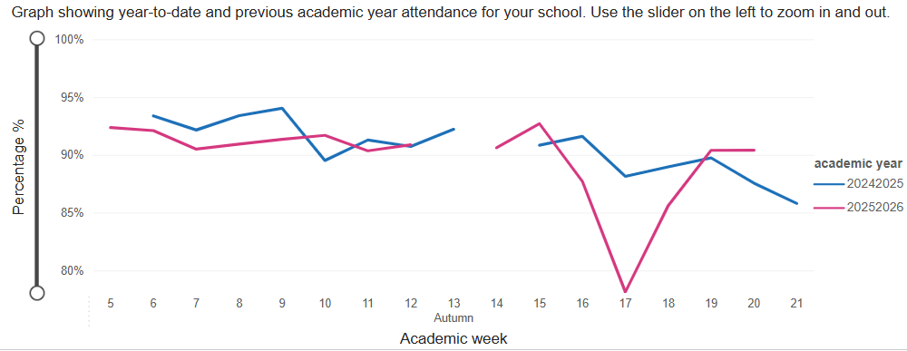 | - PA children decrease throughout the spring term and are challenged by the EWO  - Attendance YTD is improved from Spring 25  2025 91.4 whole school /91.7 CSA  2026 91.59 whole school/92.08 CSA  - PA YTD is improved from Spring 25  Spring term 2025 32% /Spring Term 2026 28.1%  - EWO Meeting x2 – allocation of EWO mentor to 2 pupils withing Y6.  - The number of suspensions will remain reduced from YTD  - Training will have been planned from Safeguarding Audit  - All staff involved in recruitment will be Safer Recruitment trained (as oppose to at least one on interview panel). JA completing training during Summer Term (next available session)  - CAMHS Action Plan to complete from CAMHS SEF  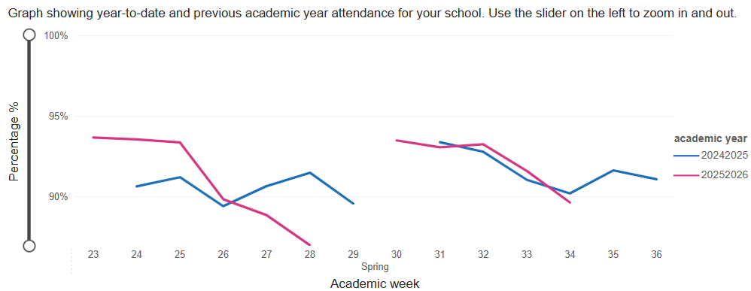  - Safeguarding Audit to complete as DSL Team |  | - LA review show the effectiveness and impact of leadership and management at all levels.  - Governance review (Governor Day 2) highlights strength in the governing body and the impact of their work  - Attendance is in line with the school target agreed with the EWO of 93% (an increase from 24/25)  - Suspensions will be below 40 days in total, and will be for less than 7 children (40 days at the end of HT 5 for 11 pupils)  - Training schedule for Safeguarding for 25/26 will be completed  - All DSLs will have had full or refresher training  - ESA Safeguarding review will show that all actions from the previous year have been addressed and are fully embedded  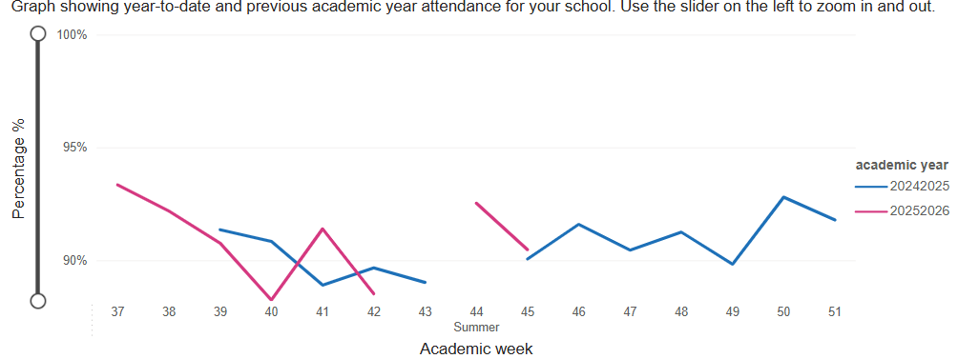  SSIA report on attendance shows ‘Urgent Attention’ needed in all areas. AHT for attendance has worked with the Headteacher to write a strategic plan for attendance, as well as the employment of an Attendance Officer from 1.6.26 to increase capacity.  Participation with RISE Team for attendance and behaviour.  Attendance at conferences across the year by AHT and HT.  Use of DfE Insights data to support data analysis.  26/27:  - Implementation of ‘Strategic Plan’ for attendance, with weekly analysis, and monthly reports.  - Safeguarding Training to be outlined on Strategic Calendar for the full year  - Clarity of roles and responsibilities within the leadership and DSL/Pastoral teams with a focus on attendance and behaviour

