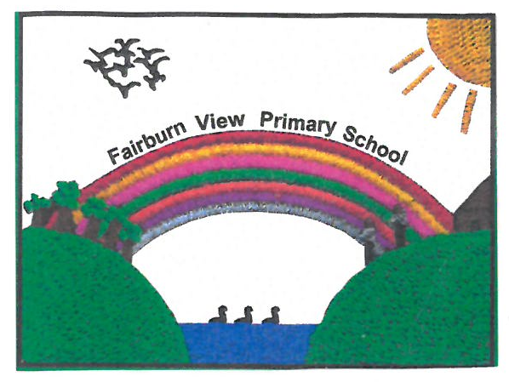

**Fairburn View Primary School**

**Model Whistleblowing Policy for Schools**

**May 2024**

**Version: 2.4**

**Prepared By: Julie Pratt - SBM**

**Date Taken to Governors: 21/05/2024**

**Signed by: ______________________**

**Head Teacher – M Brownlee**

**Signed by: ______________________**

**Chair of Governors – Jonathan Foster**

**Review Date: May 2025**